**Accounting And Financial Analytics with Zoho Books**

**ASSIGNMENT-1**

**TASK 1- STOCK MARKET ANALYSIS**

**OBJECTIVE**: Analyzing the performance of GOOGLE over the past year.

**INTRODUCTION**

**GOOGLE**:

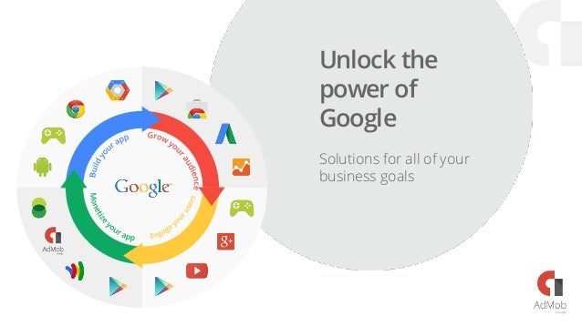

The search engine went through many updates in attempts to eradicate [search engine optimization](https://en.wikipedia.org/wiki/Search_engine_optimization).

Google has engaged in partnerships with [NASA](https://en.wikipedia.org/wiki/NASA), [AOL](https://en.wikipedia.org/wiki/AOL), [Sun Microsystems](https://en.wikipedia.org/wiki/Sun_Microsystems), [News Corporation](https://en.wikipedia.org/wiki/News_Corporation), [Sky UK](https://en.wikipedia.org/wiki/Sky_UK), and others. The company set up a charitable offshoot, [Google.org](https://en.wikipedia.org/wiki/Google.org), in 2005.

The name Google is a misspelling of [Googol](https://en.wikipedia.org/wiki/Googol), the number 1 followed by 100 zeros, which was picked to signify that the search engine was intended to provide large quantities of information.

**KEY BUSINESSES**

Google's primary business revolves around online advertising, specifically through its advertising platform called Google Ads. This platform allows businesses to display ads on Google's search engine results pages, as well as on other Google-owned properties such as YouTube, Gmail, and various partner websites within the Google Display Network.

Google Ads operates on a pay-per-click (PPC) model, where advertisers bid on keywords and pay Google each time a user clicks on their ad. Google uses sophisticated algorithms to display ads that are relevant to users' search queries or browsing behavior, maximizing the chances of advertisers reaching their target audience

In addition to advertising, Google also offers a wide range of products and services, including:

*Search Engine: Google's search engine is one of its core products, allowing users to search the web for information, images, videos, and more.*

1. *Google Cloud Platform: Google provides cloud computing services, including infrastructure as a service (IaaS), platform as a service (PaaS), and software as a service (SaaS) offerings.*
2. *Android: Google's mobile operating system, which powers a significant majority of smartphones and tablets worldwide.*
3. *YouTube: The world's largest video-sharing platform, owned by Google, which allows users to upload, share, and view videos.*
4. *Google Maps: A mapping service offering satellite imagery, street maps, real-time traffic conditions, and route planning for users worldwide.*
5. *Google Workspace (formerly G Suite): A suite of productivity tools including Gmail, Google Drive, Google Docs, Google Sheets, Google Slides, and more, designed for businesses and organizations*

**DATA ANALYSIS**

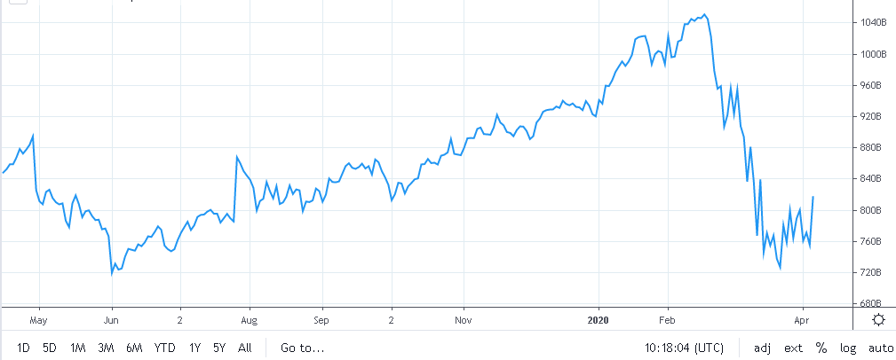

**HISTORICAL PRICE DATA**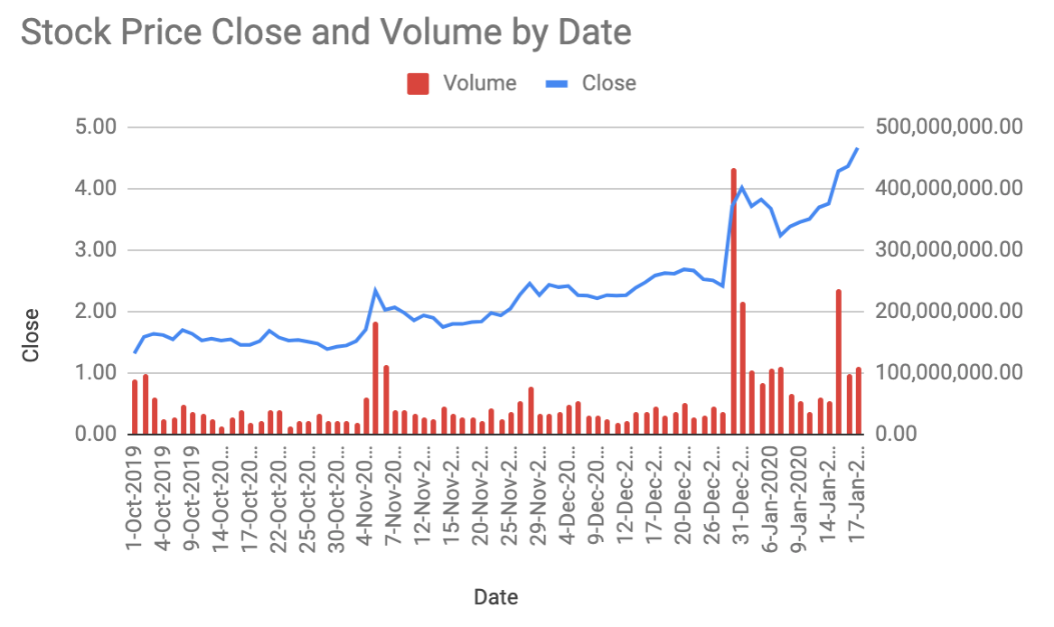

**KEY METRICS**

Google, now known as Alphabet Inc. after a corporate restructuring, is one of the world's largest and most influential technology companies. When analyzing Google (Alphabet) stock, there are several key metrics investors typically consider:

1. **Revenue Growth**: This metric shows how fast the company's revenue is growing over time. Google's revenue growth is often a reflection of its ability to monetize its various products and services, such as advertising through Google Ads and cloud services through Google Cloud.
2. **Profitability**: Investors typically look at metrics such as net income and operating income to gauge the company's profitability. Google's profitability is closely watched as it reflects the effectiveness of its business model and operational efficiency.
3. **Operating Margins**: Operating margins indicate how efficiently the company is managing its costs relative to its revenue. Higher operating margins suggest better efficiency and potentially greater profitability.
4. **Free Cash Flow**: Free cash flow represents the cash a company generates from its operations after accounting for capital expenditures. Positive free cash flow indicates that the company has enough cash to reinvest in its business, pay dividends, and reduce debt.
5. **User Metrics**: For Google, user metrics such as monthly active users (MAUs) for its various products like Google Search, YouTube, and Google Maps are important indicators of engagement and potential revenue growth.
6. **Cost per Click (CPC)**: This metric is particularly relevant for Google's advertising business. It measures the average price advertisers pay each time a user clicks on their ad. Changes in CPC can indicate shifts in demand for advertising and the effectiveness of Google's advertising platforms.

| **ALPHABET HISTORICAL ANNUAL STOCK PRICE DATA** | | | | | | |
| --- | --- | --- | --- | --- | --- | --- |
| **Year** | **Average Stock Price** | **Year Open** | **Year High** | **Year Low** | **Year Close** | **Annual % Change** |
| 2024 | 144.7190 | 139.5600 | 156.5000 | 132.5600 | 155.8700 | 10.60% |
| 2023 | 119.6119 | 89.7000 | 142.8200 | 86.7700 | 140.9300 | 58.83% |
| 2022 | 115.1937 | 145.0745 | 148.0365 | 83.4900 | 88.7300 | -38.67% |
| 2021 | 125.5307 | 86.4120 | 150.7090 | 86.4120 | 144.6795 | 65.17% |
| 2020 | 74.0702 | 68.3685 | 91.3995 | 52.8310 | 87.5940 | 31.03% |
| 2019 | 59.4197 | 52.2925 | 68.0585 | 50.8030 | 66.8510 | 29.10% |
| 2018 | 55.6613 | 53.2500 | 63.4165 | 48.8110 | 51.7805 | -1.03% |
| 2017 | 46.0891 | 39.3070 | 53.8570 | 39.3070 | 52.3200 | 35.58% |
| 2016 | 37.1743 | 37.0920 | 40.6555 | 33.4130 | 38.5910 | 1.71% |
| 2015 | 30.1231 | 26.2405 | 38.8300 | 24.6275 | 37.9440 | 44.16% |

1. **Cloud Revenue**: Google Cloud Platform's revenue growth is an increasingly important metric as the company competes with other cloud service providers like Amazon Web Services (AWS) and Microsoft Azure.
2. **Other Bets**: Alphabet's "Other Bets" segment includes various experimental projects and subsidiaries such as Waymo (self-driving cars) and Verily (life sciences). Although this segment typically represents a small portion of Alphabet's revenue, investors may monitor its progress for potential future growth opportunities.

**Valuation Metrics**: Investors often look at traditional valuation metrics such as price-to-earnings (P/E) ratio, price-to-sales (P/S) ratio, and enterprise value-to-EBITDA (EV/EBITDA) ratio to assess whether a stock is overvalued or undervalued relative to its peers and historical performanceop of Form

**VOLATILITY**

Volatility in the context of stock prices refers to the degree of variation in trading price observed over time. It's typically measured using statistical metrics such as standard deviation or variance. Higher volatility indicates larger fluctuations in price, while lower volatility suggests more stable price movements.

To calculate the volatility of GOOGLE stock, you would typically gather historical stock price data over a specific period and then compute the standard deviation or variance of the stock's returns over that period. The returns can be calculated as the percentage change in price from one trading day to the next.

GOOGLE is currently trading at Rs 3922.35, marking a 1.0% change today. Over the past 3 months, the average daily volatility stands at 2.65 units.

**GOOGLE IV Percentile Rank**

GOOGLE implied volatility (IV) is 52.8, which is in the **16%** percentile rank. This means that 16% of the time the IV was lower in the last year than the current level. The current IV (52.8) is -26.8% below its 20 day moving average (72.1) indicating implied volatility is **trending lower**.

**GOOGLE IV vs 20-Day HV**

The current IV (52.8) in GOOGLE is -31.4% below its 20 day HV (76.9) suggesting that options markets are predicting future volatility to trade below the most recent 20 day realized volatility.

**GOOGLE IV vs 252-Day HV Divergence**

Traders frequently use the difference between implied volatility and historical volatility to measure divergence from the mean. Using the 252 HV as the long term benchmark, the implied volatility (52.8) is currently -28.3% below the 252 day HV (73.6) mean.

* **AVERAGE TRADING VOLUME**

DAILY PERCENTAGE AND VOLUME ANALYSIS

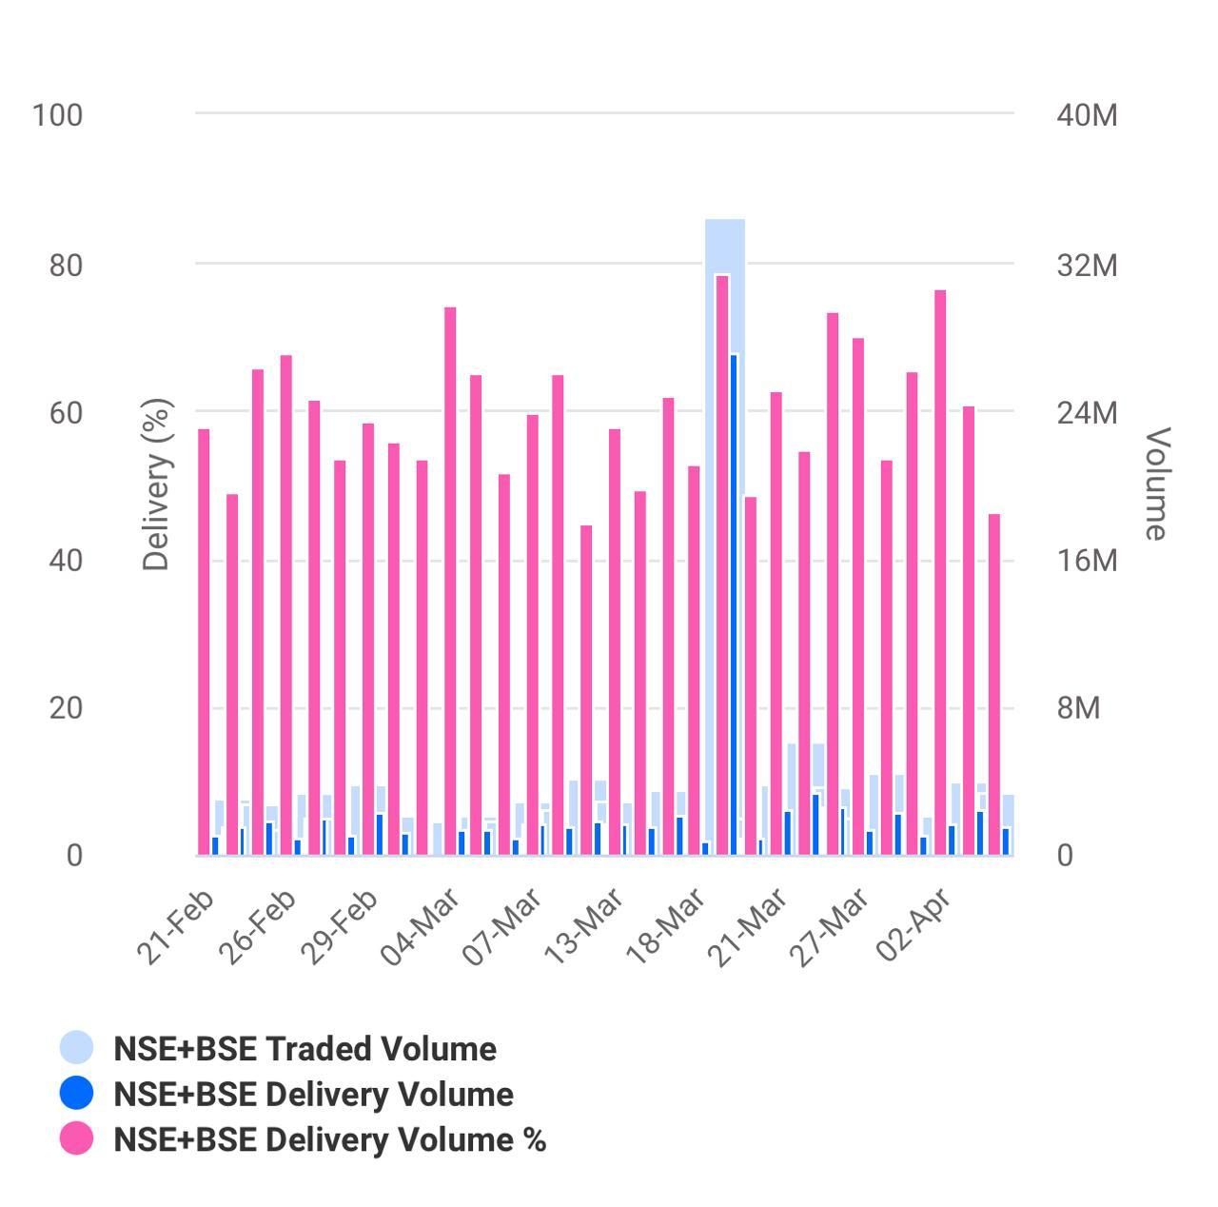

**4. STOCK COMPARISON WITH RELATED STOCK INDEX**



|  |  |  |  |  |  |  |  |  |  |
| --- | --- | --- | --- | --- | --- | --- | --- | --- | --- |
| Symbol | GOOGLE | NFTY | |  | |  | |  | |
| Company | The Container Store Group Inc | FT India Nifty 50 EW ETF | |  | |  | |  | |
| **Price Information** |  | | | | | | | | |
| Exchange | NYSE | | NASDAQ | |  | |  | |  |
| Open | 1.1400 | | 57.30 | |  | |  | |  |
| High | 1.2000 | | 57.51 | |  | |  | |  |
| Low | 1.1400 | | 57.30 | |  | |  | |  |
| Last | 1.1900 | | 57.42 | |  | |  | |  |
| Change | +0.0900 | | +0.13 | |  | |  | |  |
| % Change | +8.18% | | +0.23% | |  | |  | |  |
| Volume | 104,937 | | 5,463 | |  | |  | |  |
| 20-Day Average Volume | 361,171 | | 25,218 | |  | |  | |  |
| Previous Close | 1.1000 | | 57.29 | |  | |  | |  |
| Industry | Consumer Prdts - Misc Discr | | N/A | |  | |  | |  |
| Has Options | Yes | | Yes | |  | |  | |  |
| **Technicals** |  | | | | | | | | |
| 20-Day Moving Average | 1.1155 | | 56.62 | |  | |  | |  |
| 20-Day Raw Stochastic | 66.47% | | 72.85% | |  | |  | |  |
| 20-Day Relative Strength | 46.48% | | 58.39% | |  | |  | |  |
| Weighted Alpha | -59.39 | | +34.15 | |  | |  | |  |
| Today's Opinion | 88% Sell | | 96% Buy | |  | |  | |  |
| Previous Opinion | 100% Sell | | 96% Buy | |  | |  | |  |
| Last Month's Opinion | 100% Sell | | 100% Buy | |  | |  | |  |
| **Performance** |  | | | | | | | | |
| **5-Days** |  | | | | | | | | |
| %Chg | +7.26% since 03/27/24 | | +2.75% since 03/27/24 | |  | |  | |  |
| Low | 1.0700 on 04/02/24 | | 56.73 on 03/28/24 | |  | |  | |  |
| High | 1.2000 on 04/04/24 | | 57.51 on 04/04/24 | |  | |  | |  |
| **1-Month** |  | | | | | | | | |
| %Chg | -11.29% since 03/04/24 | | -0.26% since 03/04/24 | |  | |  | |  |
| Low | 0.9815 on 03/18/24 | | 55.34 on 03/19/24 | |  | |  | |  |
| High | 1.3050 on 03/05/24 | | 58.25 on 03/08/24 | |  | |  | |  |
| **3-Month** |  | | | | | | | | |
| %Chg | -51.04% since 01/04/24 | | +5.62% since 01/04/24 | |  | |  | |  |
| Low | 0.9500 on 02/07/24 | | 53.37 on 01/23/24 | |  | |  | |  |
| High | 2.4600 on 01/05/24 | | 58.25 on 03/08/24 | |  | |  | |  |
| **6-Month** |  | | | | | | | | |
| %Chg | -45.88% since 10/04/23 | | +19.34% since 10/04/23 | |  | |  | |  |
| Low | 0.9500 on 02/07/24 | | 46.60 on 10/26/23 | |  | |  | |  |
| High | 2.5200 on 12/26/23 | | 58.25 on 03/08/24 | |  | |  | |  |
| **Key Statistics** |  | | | | | | | | |
| Market Capitalization, $K | 56,773 | | 191,922 | |  | |  | |  |
| Shares Outstanding, K | 51,612 | | 3,350 | |  | |  | |  |
| Annual Sales | 1,047,260,000 | | 0 | |  | |  | |  |
| Annual Net Income | -158,860,000 | | 0 | |  | |  | |  |
| Last Quarter Sales | 214,900,000 | | N/A | |  | |  | |  |
| Last Quarter Net Income | -6,430,000 | | N/A | |  | |  | |  |
| 60-Month Beta | 1.13 | | 0.72 | |  | |  | |  |
| **Per-Share Information** |  | | | | | | | | |
| Most Recent Earnings | -0.08 on 02/06/24 | | N/A | |  | |  | |  |
| Latest Earnings Date | 05/21/24 | | N/A | |  | |  | |  |
| Most Recent Dividend | N/A | | 0.079 on 03/21/24 | |  | |  | |  |
| Next Ex-Dividends Date | N/A | | 03/21/24 | |  | |  | |  |
| **Ratios** |  | | | | | | | | |
| Price/Earnings ttm | 0.00 | | 17. | |  | |  | |  |

**5.KEY EVENTS OF GOOGLE**

Over the past few years, GOOGLE has experienced several significant events and milestones. Here are some key events that have occurred:

**Leadership Changes**: GOOGLE saw leadership changes with Rajesh Gopinathan taking over as CEO and managing director from Natarajan Chandrasekaran in February 2017. These transitions brought changes in strategic direction and focus areas.

**Expansion and Global Presence**: GOOGLE continued to expand its global footprint, opening new offices and delivery centers in various countries to serve its clients better. Expansion efforts were particularly notable in regions such as North America, Europe, and Asia-Pacific.

**Digital Transformation Initiatives**: GOOGLE intensified its focus on digital transformation, investing in new technologies such as artificial intelligence (AI), machine learning (ML), cloud computing, and Internet of Things (IoT). The company launched several digital solutions and services to help clients modernize their businesses.

**Acquisitions and Partnerships**: GOOGLE made strategic acquisitions to strengthen its capabilities and offerings. For example, in 2017, GOOGLE acquired W12 Studios, a digital design studio based in London, to enhance its digital design and customer experience capabilities. GOOGLE also formed partnerships with technology companies, universities, and startups to foster innovation and collaborate on research and development projects.

**Employee Initiatives and Training Programs**: GOOGLE continued to invest in its workforce through various employee initiatives and training programs. The company launched re skilling and up skilling programs to equip employees with in-demand digital skills and support their career growth.

**Recognition and Awards**: GOOGLE received recognition and awards for its performance, innovation, and corporate social responsibility initiatives. For instance, GOOGLE was ranked as the world's most valuable IT services brand by Brand Finance in 2020 and received accolades for its sustainability efforts and diversity and inclusion practices.

**COVID-19 Response**: Like many companies, GOOGLE navigated the challenges posed by the COVID-19 pandemic. The company swiftly transitioned to remote work arrangements, implemented safety protocols, and supported clients in adapting tothe new business environment. GOOGLE also launched several initiatives to provide relief and support to communities affected by the pandemic.

These are just a few examples of key events that have occurred in GOOGLE over the last few years. The company continues to evolve and adapt to changes in the industry and the broader business landscape.

*THANK YOU*

**BY: BORA HARI**

BBA

Dr. L. BULLAYYA COLLEGE

ANDHRA UNIVERSITY